**TEST 3**

**Name:M.prasanth**

**Regno:192210031**

**Course code:DSA0163**

**Course name:Object Oriented C++**

**METHOD OVERRIDING**

#include <iostream>

using namespace std;

class person {

public:

virtual void work() {

cout<<"person is working \n";

}

};

class employee : public person {

public:

void work() {

cout << "employee is working \n";

}

};

class manager : public person {

public:

void work() {

cout <<" manager is working \n ";

}

};

int main() {

person P;

employee E;

manager M;

person* P1=&P;

person* P2=&E;

person* P3=&M;

P1->work();

P2->work();

P3->work();

}

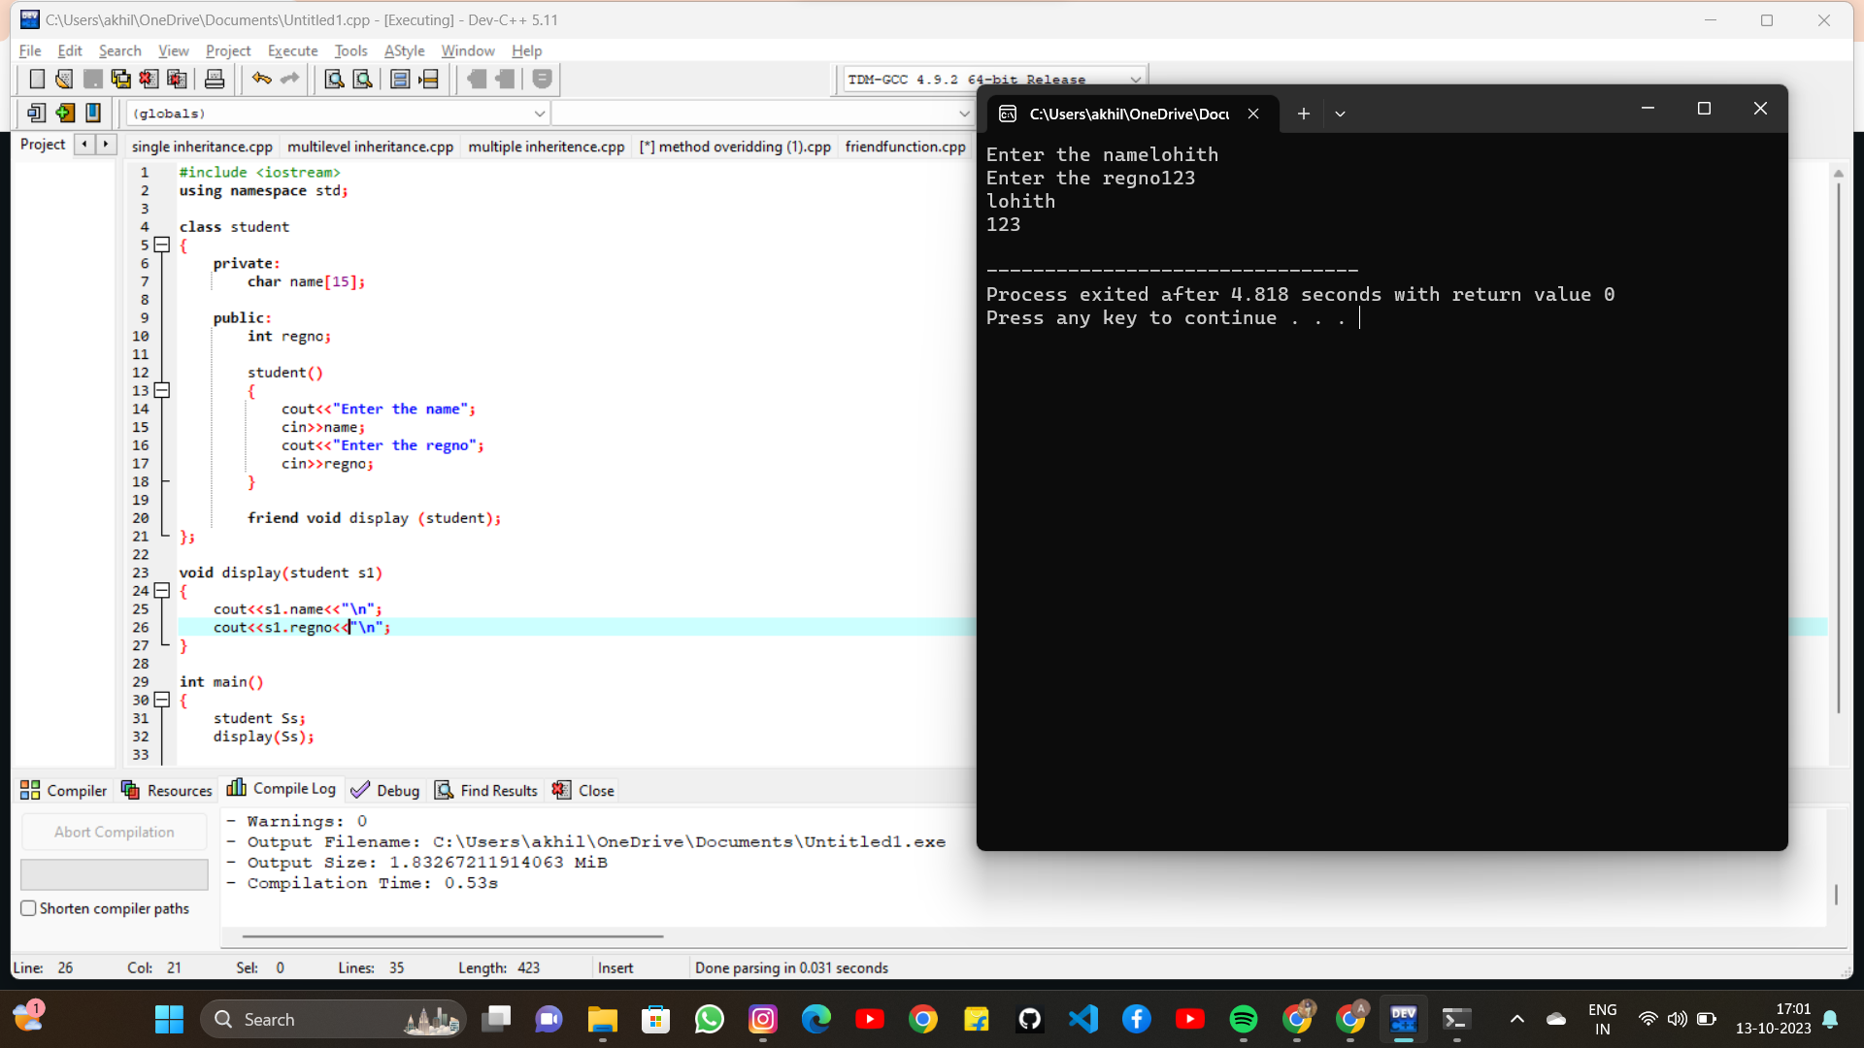

**FRIEND FUNCTION**

#include <iostream>

using namespace std;

class student

{

private:

char name[15];

public:

int regno;

student()

{

cout<<"Enter the name";

cin>>name;

cout<<"Enter the regno";

cin>>regno;

}

friend void display (student);

};

void display(student s1)

{

cout<<s1.name<<"\n";

cout<<s1.regno<<"\n";

}

int main()

{

student Ss;

display(Ss);

return 0;

}

